Title of the Practice 1: HIV Aids Awareness Program

Goal
-To make students aware of the reason through which HIV Aids spread
- To create awareness of symptoms of HIV Aids
- To make students alert about the healthy life to HIV positive person
- To build awareness of prevention of HIV Aids

Context
Infinite number of people are infected with HIV/AIDS. Therefore many children are being orphaned due to the same reason. Everyone does have knowledge of the devastating effects of HIV positive.It is estimated that 7 million South Africans are HIV positive. There is in actual sense no remedy for HIV/Aids. In such a situation the only way to overcome this disease is to spread awareness of this incurable challenge. The best method to prevent this fatal issue is to create awareness and educate people about this.
Infected people cannot live longer lives. Surveys have shown that working age groups as well as child bearing ladies are the victims of this trouble. Without spreading awareness this can never be solved. Contemplating the urgent solution to this grave issue, Dharmendrasinhji Arts College, Rajkot conducts several activities through which our team can guide undergraduates about HIV/AIDS. In 2020, Our college conducted this event digitally on MS Teams at 11:00am on 1st December,2020. The whole awareness programme was arranged by NSS Co-ordinator Dr. Farukh Khan. This function was anchored by Dr. J. S. Upadhyay. Advocate Heenaben Dave was the chief guest of the programme who gave an illuminating lecture on Touching and Eating Together Does not Spread AIDS Breaking Myths and Misconducts.
Our College also organised students’ speeches and their views on this incurable disease. At last NSS Co-ordinator Dr. Farukh Khan conducted group discussion and doubt sessions.
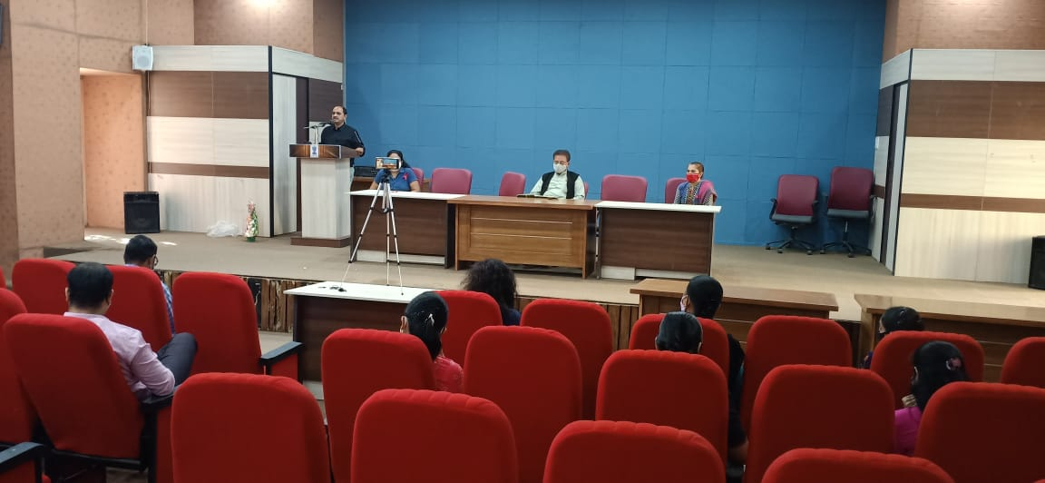
Dr. J. S. Upadhyay’s Introductory Speech on the World Aids Day
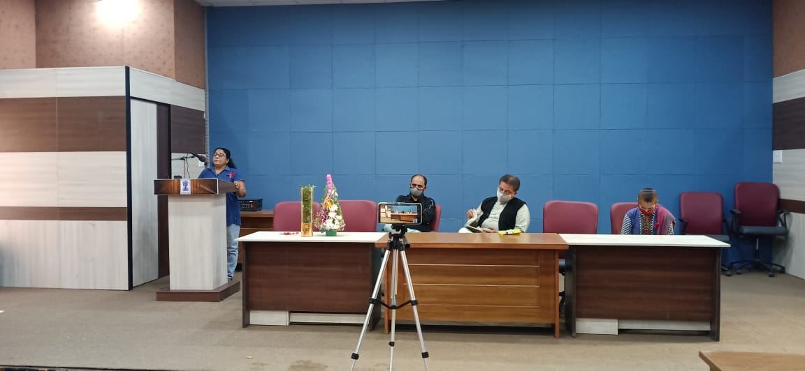
Online mode for students and Offline mode for the staff of the college
All the faculty members maintained the social distance

Practice / mechanism of organisation and implementation:

Every year this function was conducted by The Red Ribbon and N.S.S. (jointly organised HIV Aids awareness programs.) This program is run by members of Red Ribbon, N.S.S. officers Dr. Faruk Khan & his team and the entire college’s staff members and students. However in the year 2020 this was conducted digitally.
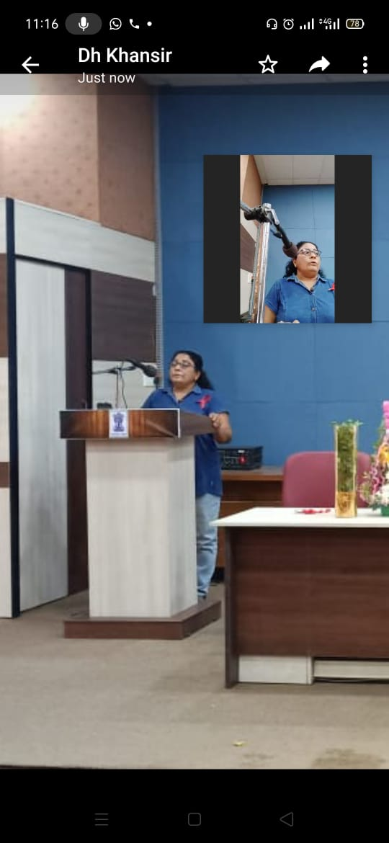
The Chief Guest- Advocate Heenaben Dave

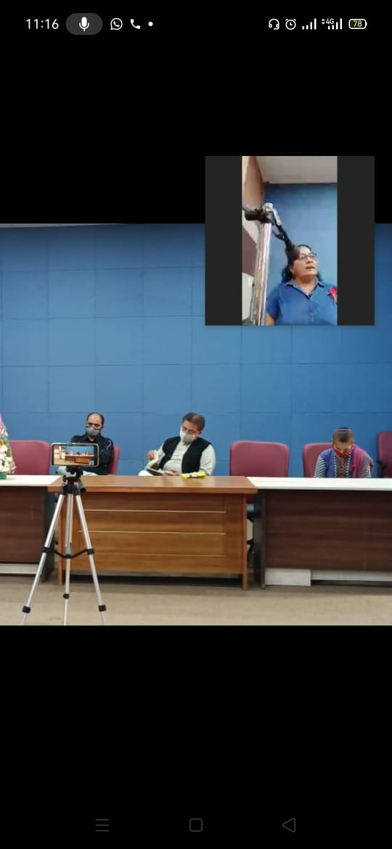
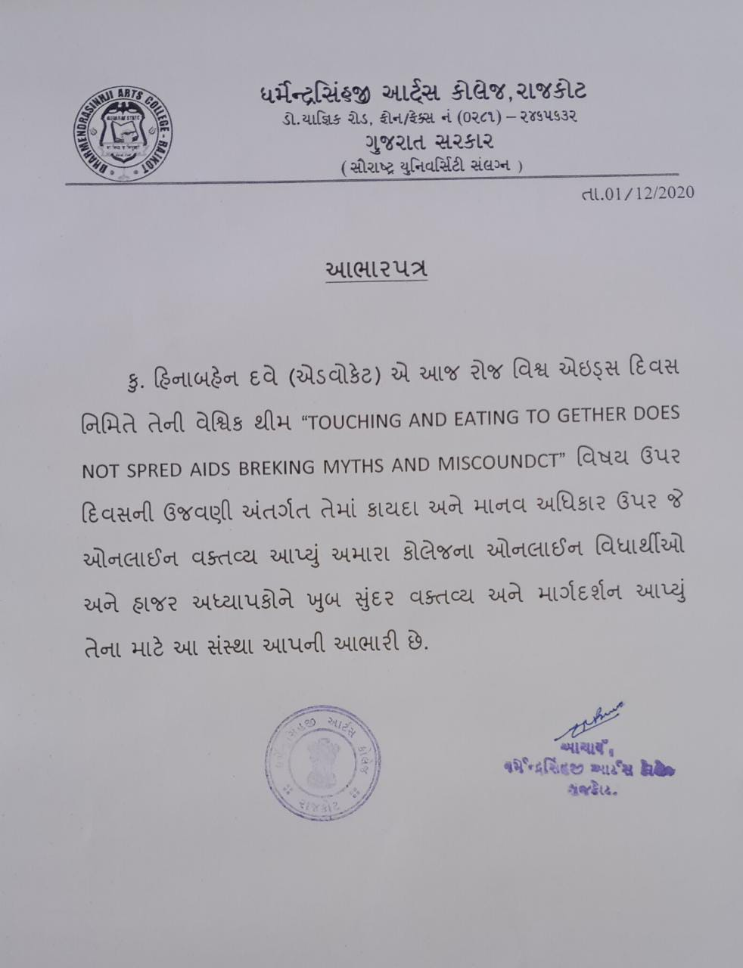
Thanks Letter given to Advocate Heenaben Dave

Evidence of success/ beneficiaries:
The biggest advantage of this awareness programme is noticed in the behaviour of college going students. They become alert about their perception regarding HIV/AIDS and learn how to treat HIV/AIDS patients.
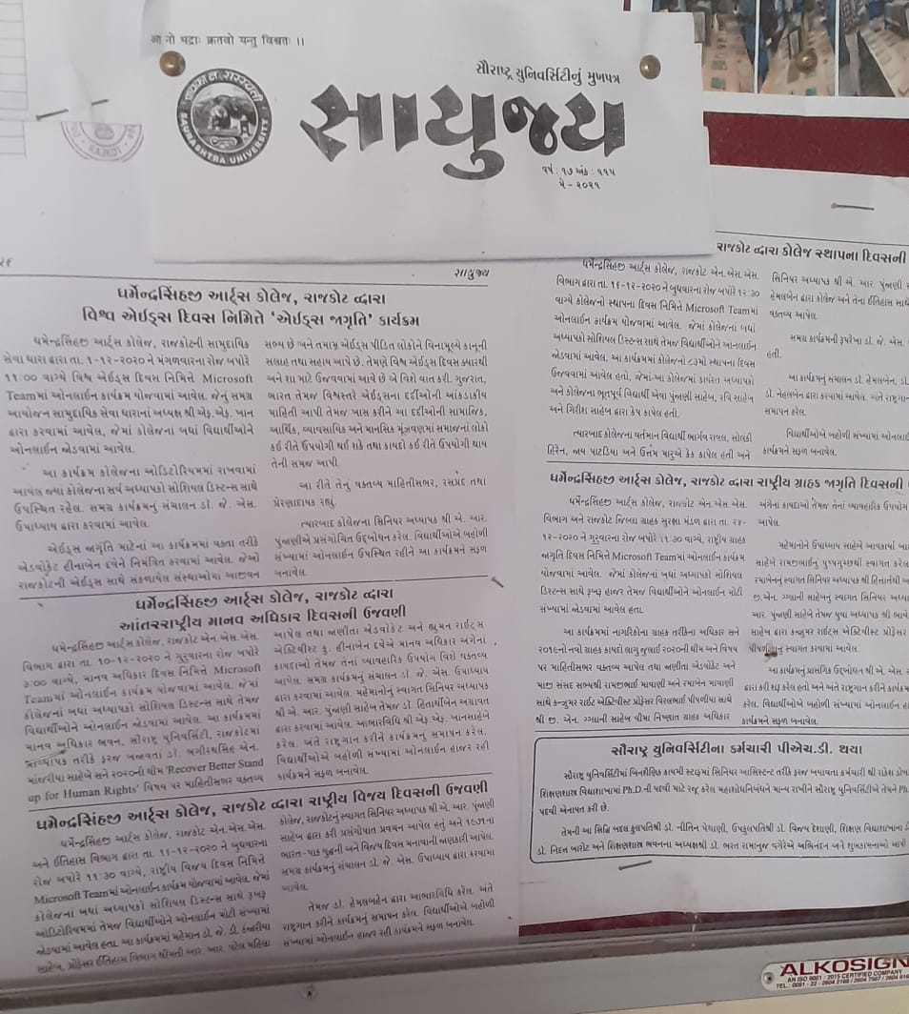
This programme was also noted in Sayujya- the Mukhpatra of Saurashtra University

Problems encountered & resources required:
One problem one can encounter is that girls students are less expressive to this disease and unable to ask the experts candidly.

